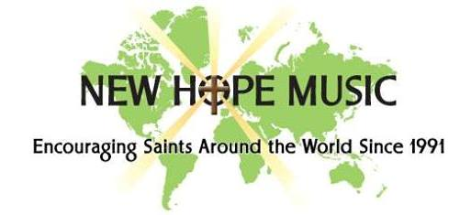
500 original, Scripture-based
songs & hymns
All FREE to download
(MP3 recordings, sheet music, guitar chords, lyrics)
Our songs have been translated into 27 languages &
sung by worship teams, choirs & youth ministries,
touching millions of people in 230 countries
Please help us share them with others ☺
--------------------
Web Site: newhopemusic.com
Recordings and Videos: reverbnation.com/newhopemusic
Facebook: https://www.facebook.com/pages/New-Hope-
Music/160231380684072
--------------------
A ministry of New Hope Chapel and Ralph Merrifield
30 Milk St, Westborough MA * newhopechapel.net
500 original, Scripture-based
songs & hymns
All FREE to download
(MP3 recordings, sheet music, guitar chords, lyrics)
Our songs have been translated into 27 languages &
sung by worship teams, choirs & youth ministries,
touching millions of people in 230 countries
Please help us share them with others ☺
--------------------
Web Site: newhopemusic.com
Recordings and Videos: reverbnation.com/newhopemusic
Facebook: https://www.facebook.com/pages/New-Hope-
Music/160231380684072
--------------------
A ministry of New Hope Chapel and Ralph Merrifield
30 Milk St, Westborough MA * newhopechapel.net

