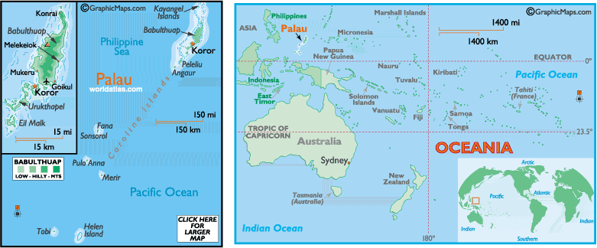
Dear Ralph Merrifield,

Hello, brother in Christ. I am a missionary starting the very first Baptist Church in the country of Palau. I am doing a search on the Internet to find music for use in our small church since we have NO book stores in our little island nation.

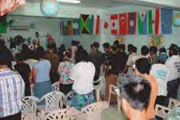
November is Friends Month at our church and we open our doors to everyone throughout the islands to join us. We currently have 14 nationalities in our body. This makes for some wonderful worshipping. During this month each year we hold our services in a unique way. First off, we try to include each of the nationalities of our church in the worship time and singing, then we learn about God's world by hearing about each of the country's needs for the Gospel. Also we learn about the beautiful things from these other places. Then after a Bible study on Friends we all gather around tasty buffet from the featured countries of the week. Wow, these events have really opened the door to many new visitors who are looking for a place to worship. You can learn more about us on our website : http://www.wbfi.net/missionaries/mcclure_t/mcclure_t.htm

We are looking for good Scriptural music for our church. If we can help you reach your goal of getting these CDs and sheet music around the world we would love to help. We have the same desire...Matthew 28:19,20
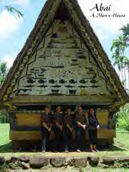
Looking forward to hearing from you.
Partners in His Service,

Rev. Terrence M. McClure, Missionary/ Pastor

Palau Baptist Church, PO Box 9025 Koror, PW 96940

