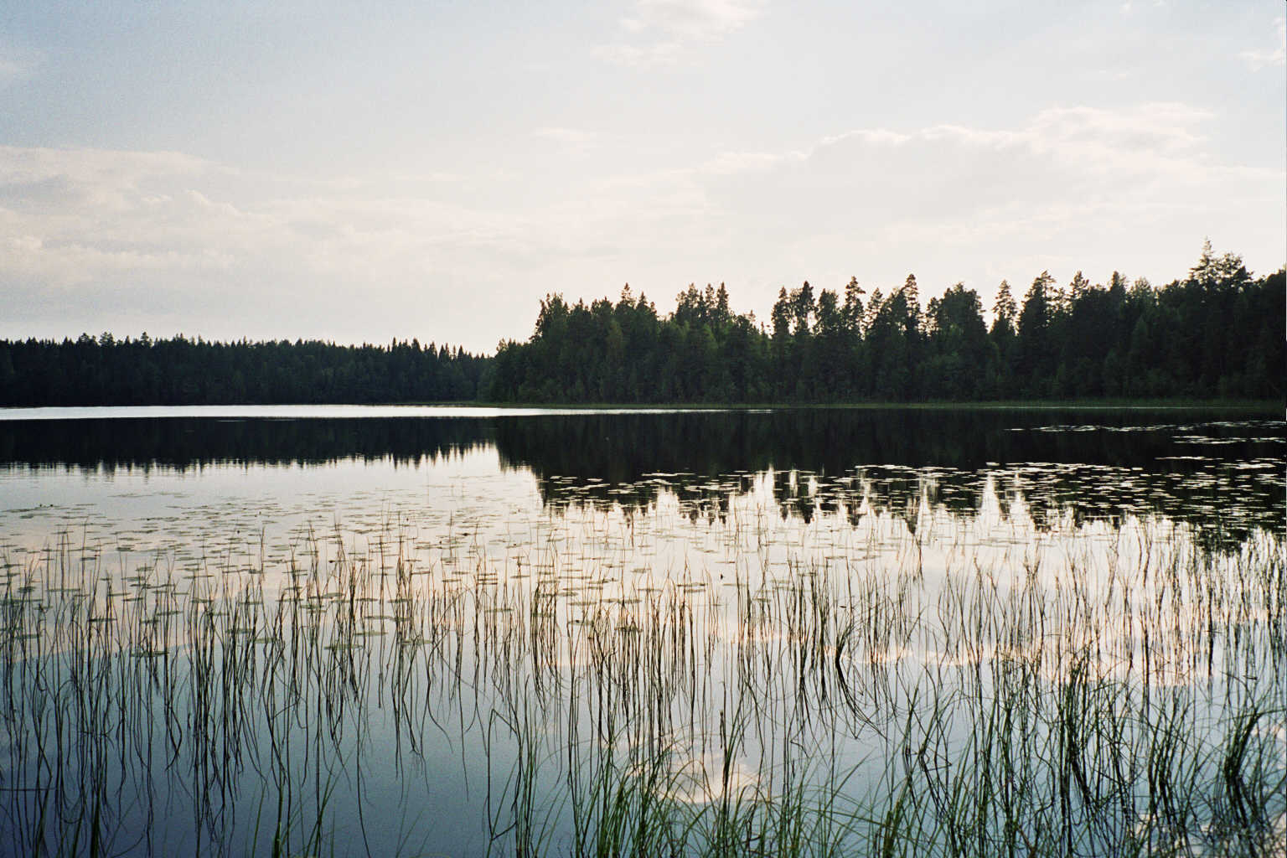

JOS ME VALKEUDESSA VAELLAMME

1. Joh. 1:5-7

Jos me valkeudessa (jos me valkeudessa)
vain vaellamme (vain vaellamme),
niinkuin Hän valkeus on (niinkuin Hän valkeus on).
niin vaellamme (niin vaellamme).
Meillä yhteys on keskenämme (meillä yhteys on keskenämme).

Valkeus, ei pimeyttä ollenkaan,
Jumala valkeus on.
Valkeus, ei pimeyttä ollenkaan,
Jumala valkeus on.

Finnish translation for Ralph Merrifield and
the precious children and students at New Covenant Christian School
with love in Christ,
Lea Alaja, Helsinki, Finland

IF WE WALK IN THE LIGHT
(based on 1 John 1:5-7)

If we walk in the light (if we walk in the light)
as He is in the light (as He is in the light)
if we walk in the light (if we walk in the light)
as He is in the light (as He is in the light)
We have fellowship with one another
We have fellowship with one another

God is light, in Him there is no darkness at all
God is light, He is light
God is light, in Him there is no darkness at all
God is light, He is light

© 2004 Ralph Merrifield, New Hope Music

