Translated into the Urdu language by Samson Ayaz, from Pakistan

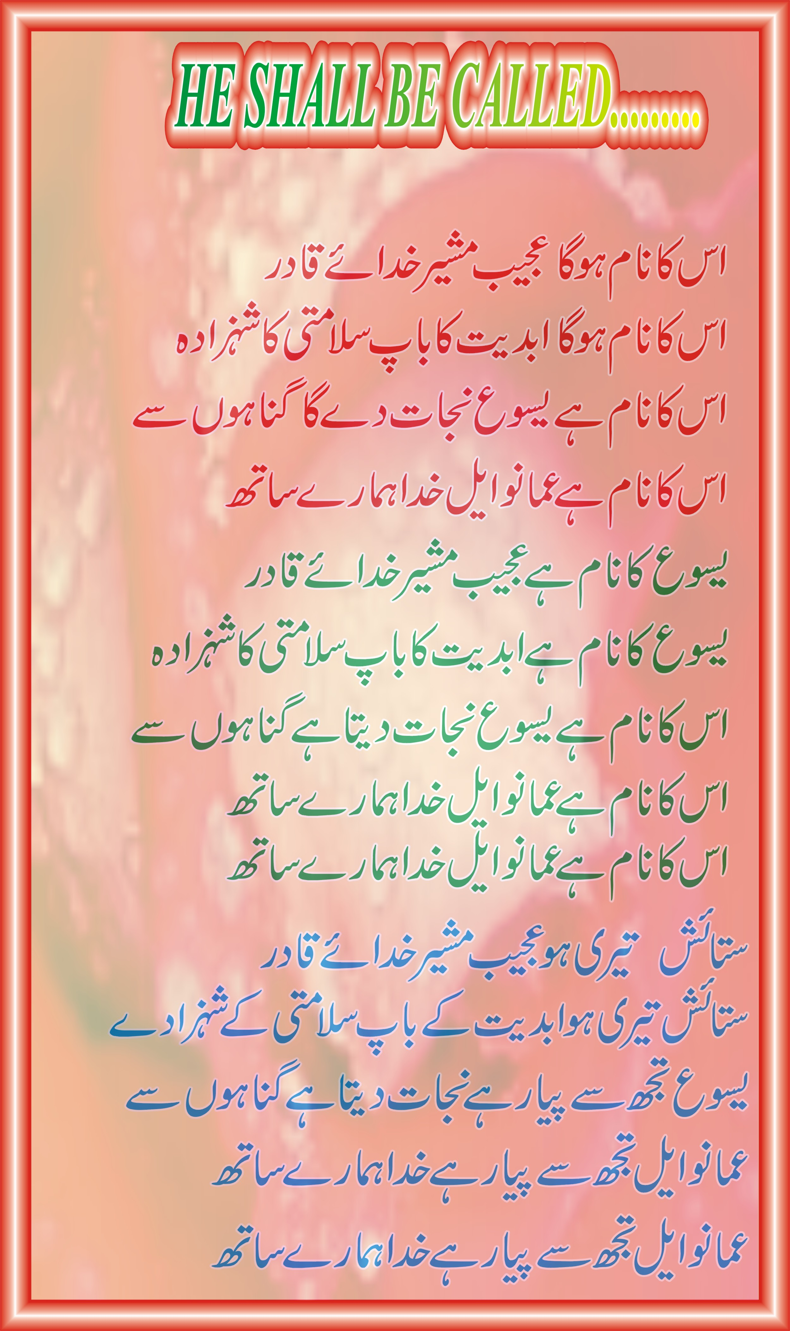

Copyright 1991, Ralph Merrifield,
New Hope Music, P.O. Box 1612, Westboro MA 01581 USA
http://newhopemusic.com

